Helmholtz Cage -

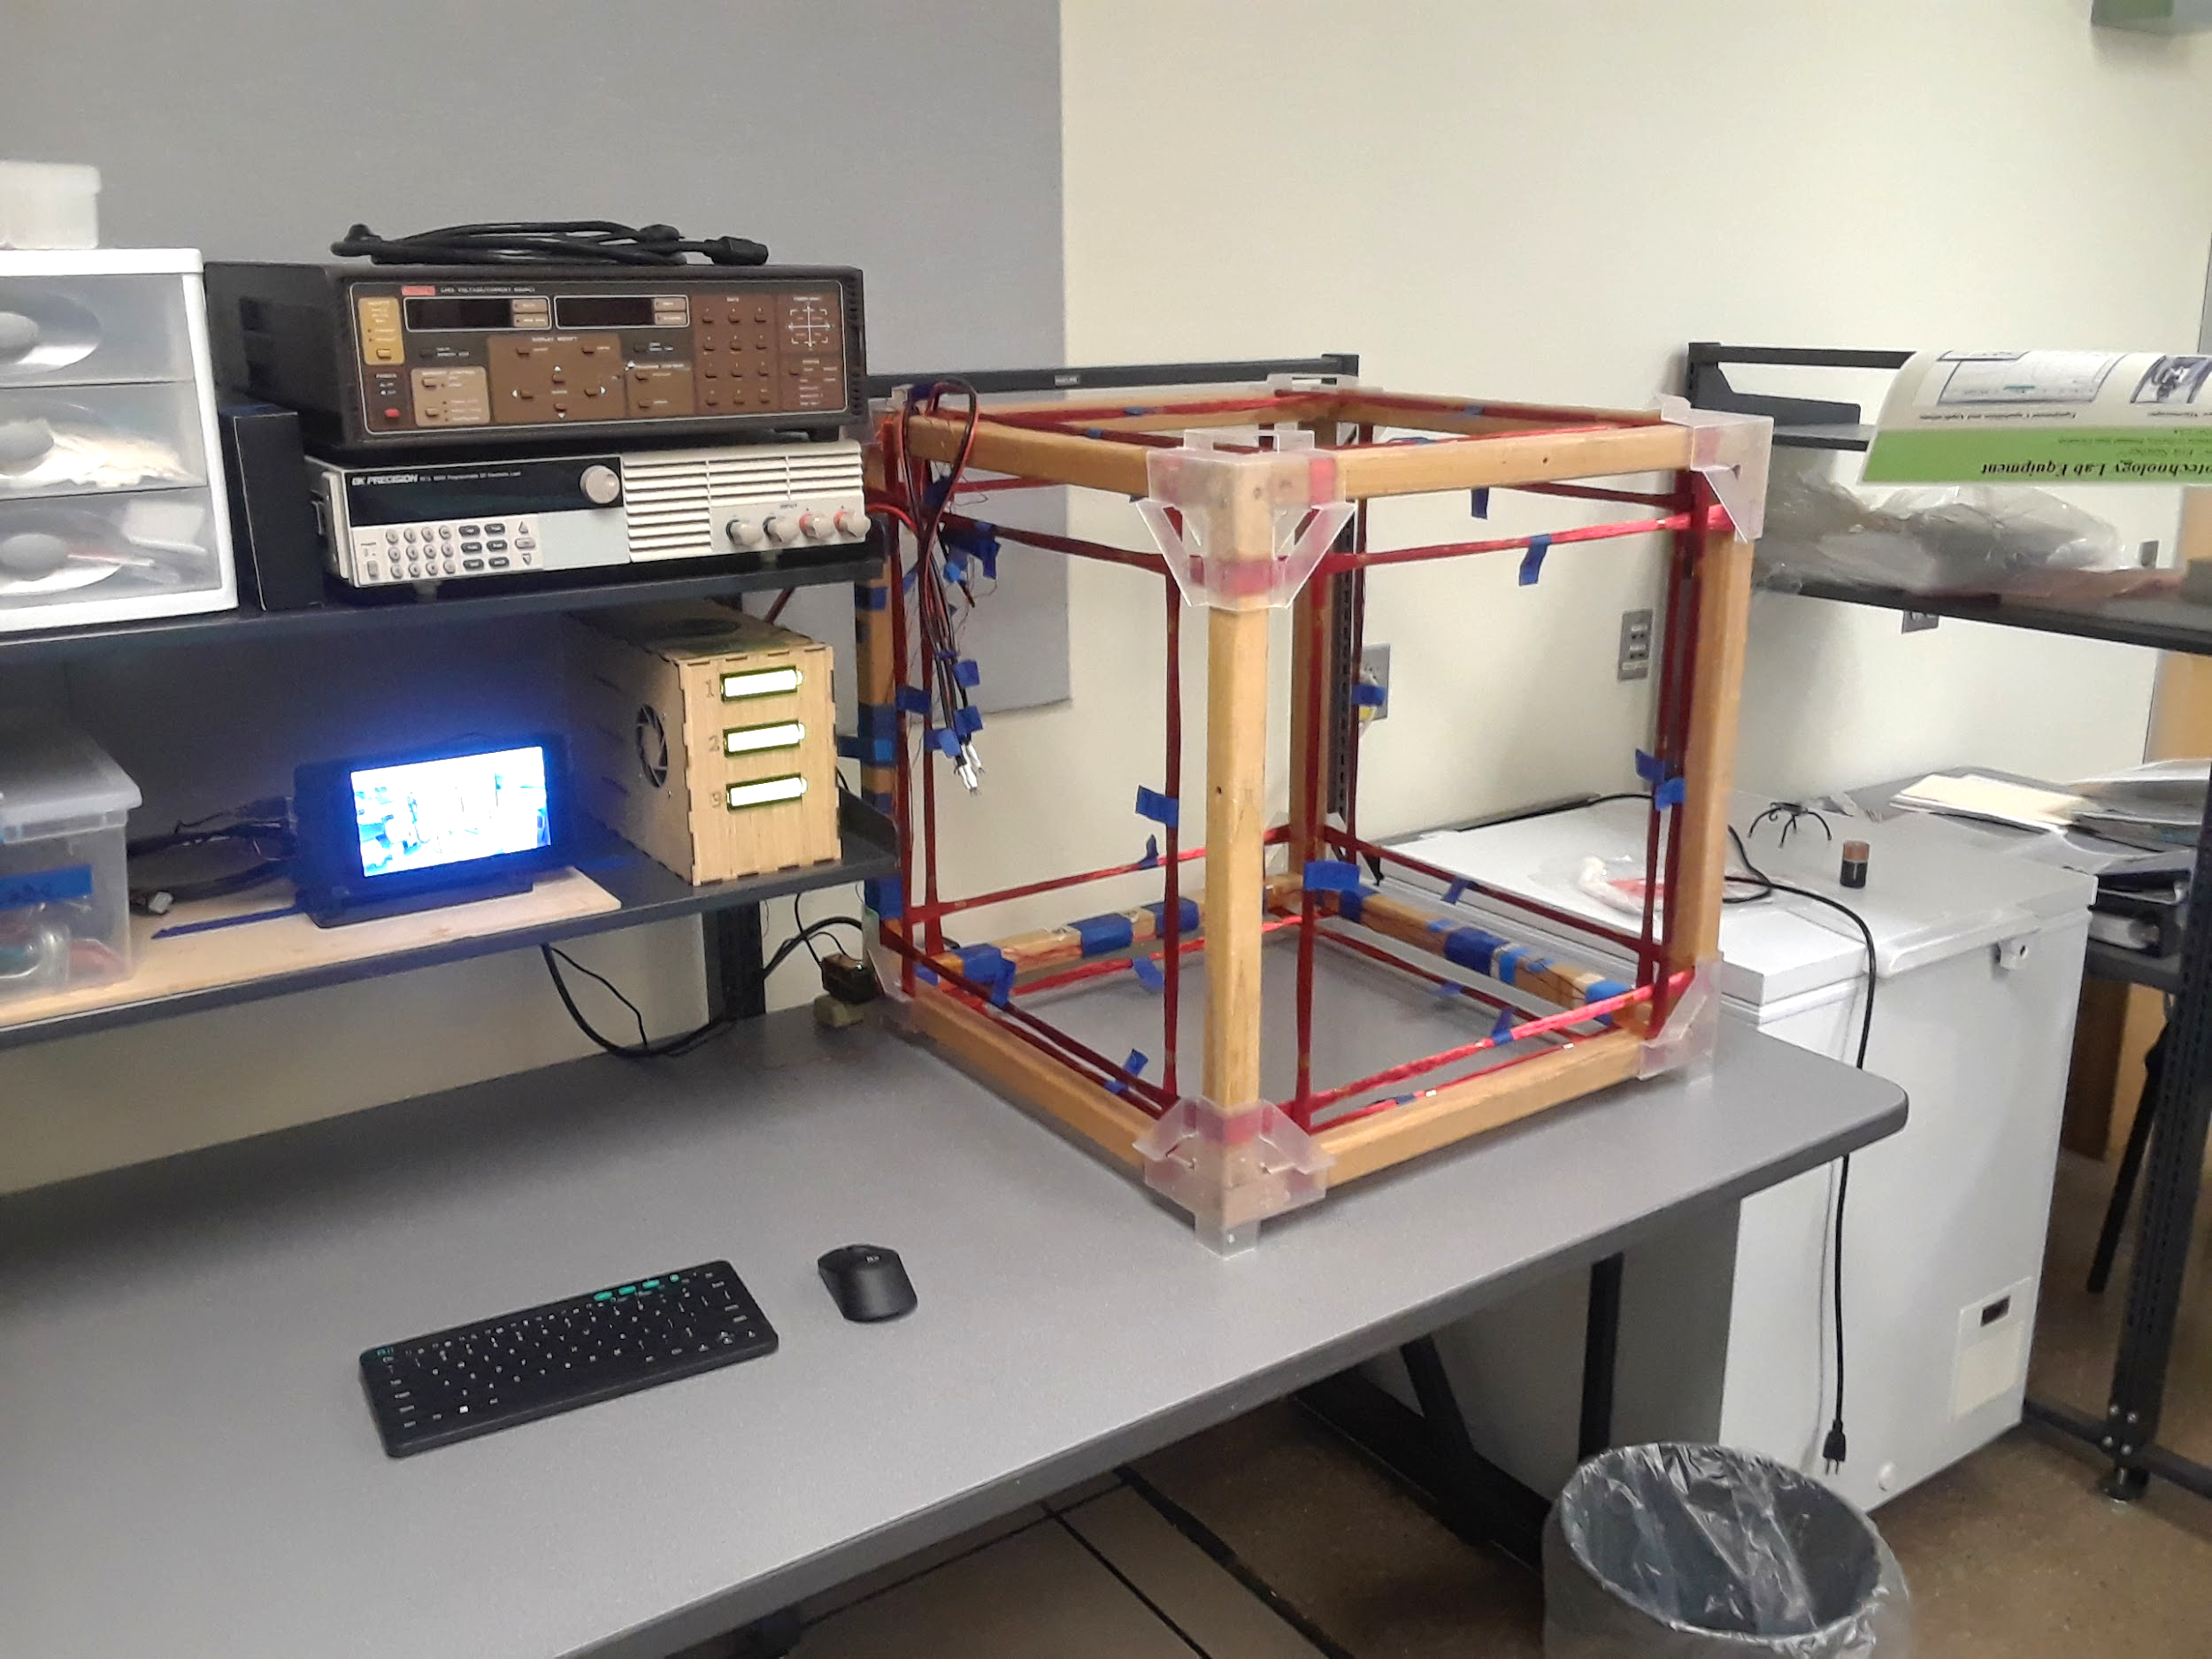OreSat (PSAS), CubeSat Testing

**Portland State University: Maseeh College of Engineering and Computer Science, January 2018 - June 2019; Portland, OR**

*Jennifer Jordan - Project Lead & Electrical/Mechanical Design, jejor2@pdx.edu*

*Bliss Brass - Firmware, brass@pdx.edu*

*Cory Gillette - Mathematical Analysis & Software, cory27@pdx.edu*

*Dmitri McGuckin - Software, dmitri.mcguckin26@gmail.com*

**Table of Contents:**

Introduction

Calculations and Our Needs

Using Helmholtz Theory...

OreSat Helmholtz Cage Specifications...

Hardware

Structure...

Coils...

Power System...

Sensors/Circuit layout...

Software

Github...

Software Features...

Troubleshooting

Data Analysis...

Discussion

Appendix

Budget:

Definitions...

OreSat Helmholtz Cage: SOP

References

Sources…

# Introduction

TBD

* + What do (what it do)
  + Helmholtz Cage Theory
  + Equations

# Calculations and Our Needs

## Using Helmholtz Theory...

* + Helmholtz Equation
  + Field needed
  + Our calculations

## OreSat Helmholtz Cage Specifications...

* Size of testing space
  + The structure’s dimensions are 26 inch^3.
  + The testing space area is 45.72 cm^3.
* Voltage/Amperes, gauge of wire, length of wire
  + 18 AWG Magnet Wire, 56 turns, 502.5 feet length.
* Operating Limits
  + Limitations/Accuracy
    - Max 60V, 5A Buck Converters.
    - Enclosed AC DC Converter 1 Output 48V 7.3A 90 ~ 132 VAC, 180 ~ 264 VAC, 240 ~ 370 VDC Input, 350W.
  + Temperature
    - Sensors
      * Power supply housing warning at 35 degrees C (95 degrees F), shutdown at 40 degrees C (104 degrees F).
      * Wire warning at 100 degrees C (212 degrees F), shutdown at 120 degrees C (248 degrees F).
    - Component Limits
      * Wire max temperature at 155 degrees C (311 degrees F).
      * AC DC Converter temp rating between -25 degrees C to 70 degrees C (-13 degrees F to 158 degrees F).
      * Buck Converters temp rating between 0 to 40 degrees C (32 degrees F to 104 degrees F).
      * MAG3110 Magnetometer temp rating between -40 degrees C to 85 degrees C (-40 degrees F to 185 degrees F).
      * MCP9808 Temperature Sensor temp rating between -40 degrees C to 125 degrees C (-40 degrees F to 257 degrees F).
  + Sensor sensitivity
    - MAG3110
      * Measurement range from -1000 uT to 1000 uT.
      * Sensitivity between -0.1 uuT to 0.1 uuT.
    - MCP9808
      * Measurement range from -40 degrees C to 125 degrees C (-40 degrees F to 257 degrees F).
      * Sensitivity between -0.25 degrees C to 0.25 degrees C (-0.9 degrees F to 0.9 degrees F).

# Hardware

## Structure...

* + Structural
    - Materials of Testing Space
      * Basic wood structure bonded with Gorilla wood glue. Any metal screws, nails, etc. would slightly disrupt the magnetic field and is best to be avoided. There are notches milled out for the wire to be held within on each strip of the structure. These notches are lined with kapton tape to assist with thermal safety measures, any wood surface that the wire comes in contact with is lined with this tape.

The structure’s dimensions are 26 inch^3. The testing space area is 45.72 cm^3.

* + - * There are also corner braces on the wood structure to further maintain the structure shape; these are made using FormLabs 3d Printer with clear resin material. See Coils for information on the wire specifications.
      * The calibration stand is used to calibrate the initial condition of the testing space. The stand is placed in the center of the testing space and reads the current magnetic field to calibrate the testing space. The calibration stand is made using Ultimaker3 3d Printer with PLA material. There are plastic screws and nuts, instead of metal, holding the joints together to avoid any magnetic field disruption. The magnetic sensor that is used is a MAG3110 3-Axis digital magnetometer (I2C) sensor (see sensors for more information).
    - Housings and Control Structures
      * Power system housing

This housing holds a 48V AC to DC power supply, three ZXY6005S DC Buck Converters, a 7 port USB 2.0 Hub, and two generic fans.

The housing is made from pressed bamboo sheets, cut using a laser cutter, and bonded with wood glue. The buck converters are held down using the PCB mounts.

There are two fans installed in the walls of the power system housing. The fans are generic 80x15mm brushless motor 12V 0.4A. These fans are present because the buck converters do not come with a cooling system, the fans are an extra safety measure to ensure that the housing operates within safe temperature conditions. These fans are powered by a USB Hub that is within the housing.

There is one temperature sensor present in the housing. The sensor will issue a warning to the user if the temperature is approaching 35 degrees C (95 degrees F) and will automatically power down the buck converters if the temperature exceeds 40 degrees C (104 degrees F) (see sensors for more information).

There are three VNH5019 Motor Drivers installed after the buck converters before the coils to enable software control of the direction of current, and hence of the direction of magnetic fields.

* + - * Display

The system is controlled using a Raspberry Pi 3 Model B. This system uses a touchscreen display and Pi housing with keyboard and mouse. See Sensors/Circuit Layout for the layout diagram.

## Coils...

* + Wires
    - The wire used is 18 AWG enameled copper magnet wire. The wire is base copper with polyurethane/polyamide overcoat. The wire has a temperature rating of 155 degrees C (311 degrees F).
    - There is one temperature sensor (MCP9808) on a coil of wire. This sensor is able to sense temperatures between -45 degrees C and 125 degrees C. This sensor will issue the user a warning if the temperature is approaching 100 degrees C (212 degrees F) and will power down the buck converters if the temperature exceeds 120 degrees C (248 degrees F). This safety measure is in place to prevent the coils from melting the enamel and exposing the wire. If any part of the wire is exposed, the cage is unable to produce a controllable magnetic field, may damage the other components, and the wire must be replaced immediately.
  + Coil Orientation diagram
    - f
  + Resistance of Coils
    - The Pairs of Coils are in parallel to maximize the current supplied to each coil

|  |  |
| --- | --- |
| Axis | Resistance ($Ω$) |
| X-Axis | 1.7 |
| Y-Axis | 1.8 |
| Z-Axis | 1.8 |

## Power System...

* + Power system
    - Power Supply
    - Adjustable buck converters
    - Specifications
    - Control (in software)
      * Option for manual entry using buttons on buck converter boards, did not fit our needs
    - Limitations
      * voltage/current/temperature

## Sensors/Circuit layout...

* + Sensors
    - Magnetometer
      * Calibration
    - Temperature
      * Safety warnings
      * Safety shut offs

# Software

## Github...

* + https://github.com/oresat/oresat-helmholtz

## Software Features...

* + Main system
    - Control
      * Raspberry Pi 3, python GUI system
    - Modes
      * User manually controls each axis voltage and current individually
  + Sensors
    - Magnetometer
      * Calibration/Initial Conditions
      * Magnetic field reading live graph display
    - Temperature
      * Safety warnings

# Troubleshooting

* + Troubleshooting & Testing
    - Operating conditions
    - Magnetic field
    - Temperature
    - Accuracy
    - Structural
      * Wire testing

## Data Analysis...

* + Accuracy testing results
  + Attitude Control System testing (actual use)

# Discussion

Future Improvements:

* + Integrating drivers to switch current direction by program instead of user.
    - Currently, to switch the field vector direction the user must manually switch the wire connection to the power supply. This poses a safety risk to the user and probability of component damage/failure.
  + Higher quality magnetometer
    - Currently using a MAG3110 I2C magnetometer. This sensor is great for prototyping but has a sensitivity of .1uT and noise up to 0.25 uT rms.
    - Since this cage works within the uT range, having noise and low sensitivity to the field can produce data analysis errors.
  + Desired Magnetic Field user input
    - User ability to input desired magnetic field into control program.
    - Calibration feature for current Earth’s magnetic field values, will need more precise magnetometer to accomplish this.
    - Program will calculate magnetic field vector variable values and output voltage and current needed to reach the theoretical value with sensor readings to account for error.
  + Integrating camera into testing area
    - Will connect with data output. Data will save voltage/current settings, 3-axis magnetic field readings, and camera images or video.
    - Will assist in attitude control system efficiency testing.

# Appendix

## Budget:

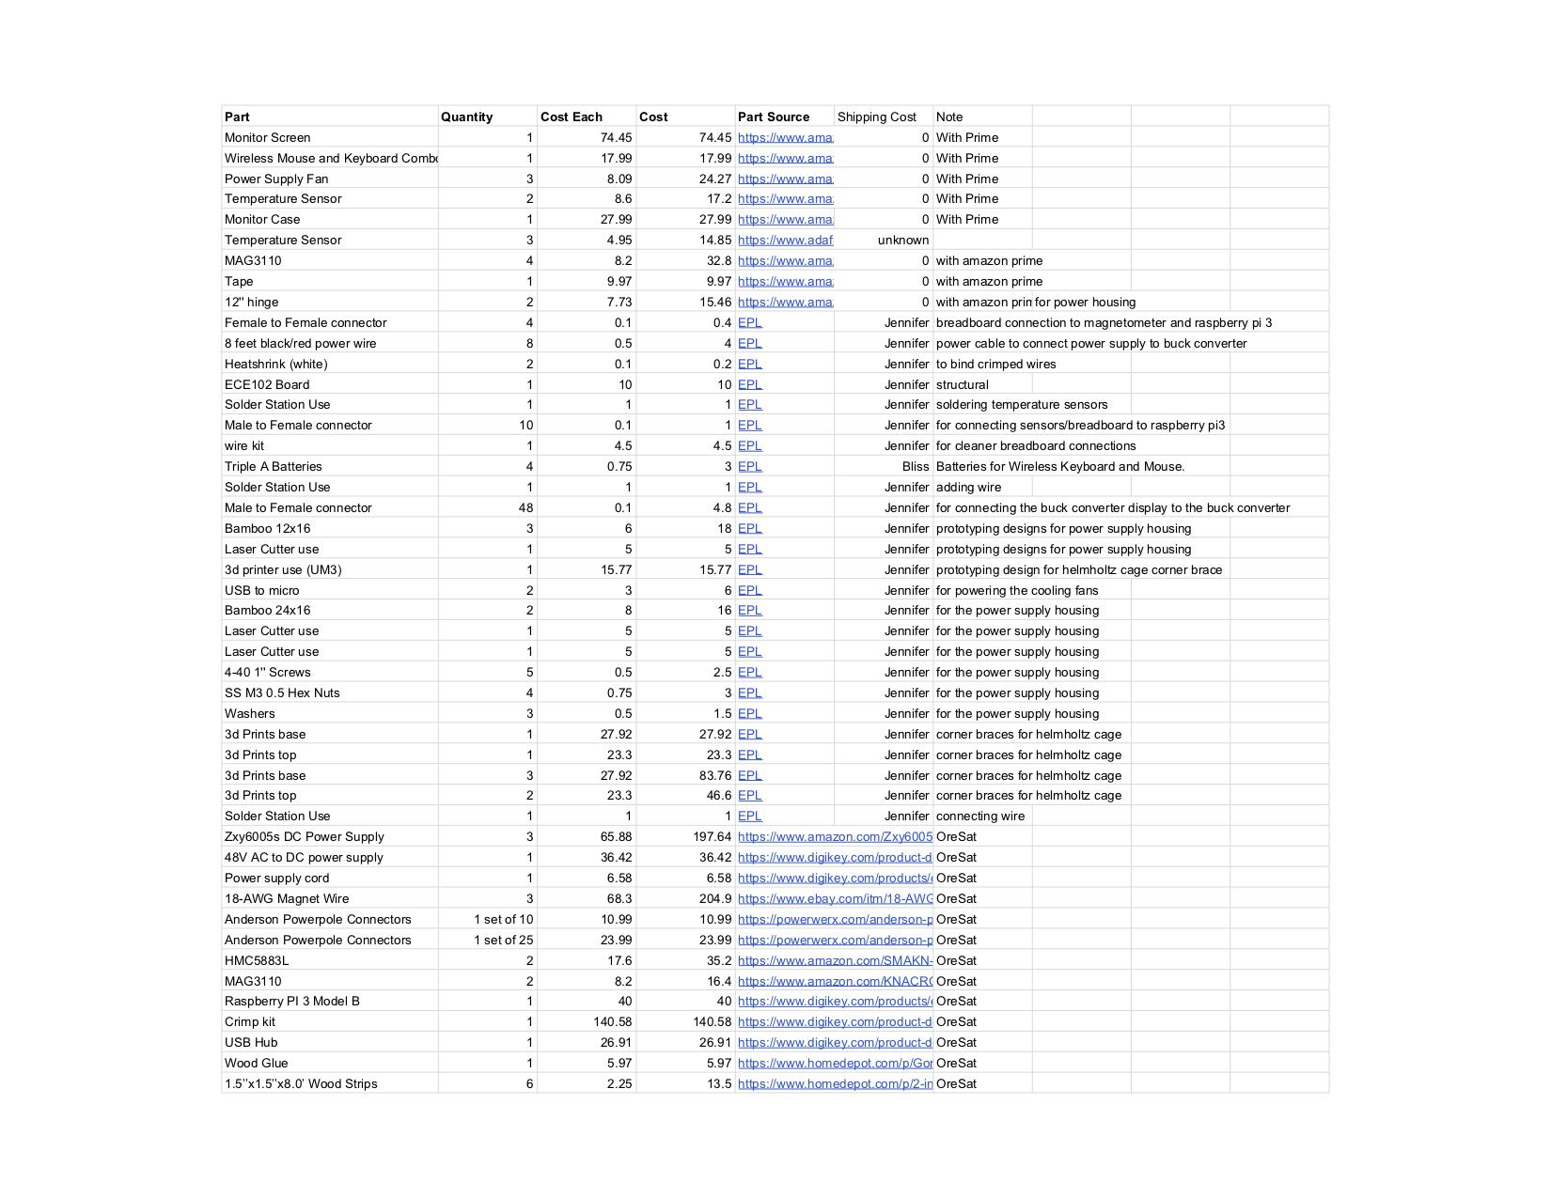

## Definitions...

* TBD

## OreSat Helmholtz Cage: SOP

General Notes

* Operate the cage with 4.92 max amps and 15.20 max volts to output the largest magnetic field vector.
* Theoretical magnetic field vector equation: 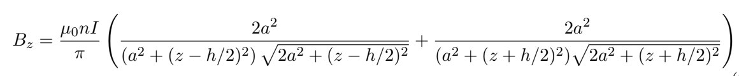
  + Bz is the total field produced by both square coils as a function of the axial distance z from the center of the coils
  + $u_{0}$ is the permeability of free space: $4π∗10^{−7}WBA^{−1}m^{−1}$
  + n is the number of turns of wire: 58 turns
  + I is the current of the wire being analyzed: user input
  + h is the distance between the coils:
  + a is one half the side length of the structure:
* Do not operate the Helmholtz Cage if the vacuum chamber is on!

Safety

* The red coils will get hot if operated for an extended period of time at high currents. Do not touch or hold the coils when operating the cage.
* Monitor the temperature of the wires to maintain a safe operating temperature below 140**°**C.
* Monitor the temperature of the main power supply to operate between -25**°**C to 70**°**C.
* If the temperature begins to approach the operating limits, turn off the power supply and let the cage cool down before resuming testing.
* Do not operate the Helmholtz Cage if the vacuum chamber is on!

Prepping the Cage

1. It is safe to put electronic devices inside and around the cage. However, they may disrupt the magnetic field and cause discrepancies in testing data. Be mindful of this and be aware of the testing space surroundings.
2. Do not operate the Helmholtz Cage if the vacuum chamber is on!
3. Verify that the coils are secured in the terminal blocks and make sure they are connected to the correct terminals/power supply. Avoid exposed and/or crossing wires!
4. Turn on the surge protector. This will power the raspberry pi, monitor, power supplies, and cage.
5. Let the raspberry pi boot up.
6. Turn the keyboard and the mouse on. There are spare batteries in the tote just in case.

Operating the Cage Program...

1. TBD

Testing & Analyzing Data...

1. TBD

While the Helmholtz Cage is Running

* Do not leave the cage unattended. You must monitor it constantly in case of a fire, to maintain safe temperatures for components, and to ensure accurate data collection.
* When the cage is running, do not touch or hold the red coils! They get hot and can cause injury/burns.
* Turn off the surge protector to immediately turn the cage off for an emergency. You may lose data, but better to lose data rather than the cage.

Finishing Up

1. Once testing is complete, turn off the raspberry pi *using the desktop menu*.
2. Wait for the raspberry pi to shutdown completely.
3. Turn off the keyboard and mouse!! Don’t waste the batteries!
4. Flip off the surge protector to power down the power supplies, monitor, and cage.
5. If you adjusted the coil placement, wait until the red wire is cool to the touch before returning the coils to their original labelled terminals.
6. Clean up after yourself and keep the workstation organized!

# References

## Sources…

Mag3110 info sheet : https://www.nxp.com/products/sensors/magnetic-sensors/high-accuracy-3d-magnetometer:MAG3110